LETSUPGRADE JAVASCRIPT ESSENTIALS

ASSIGNMENT 3

Q1Write a JavaScript program to display the reading status (i.e. display book name, author name,

and reading status) of the following books.

var library = [

{

author: 'Bill Gates',

title: 'The Road Ahead',

readingStatus: true

},

{

author: 'Steve Jobs',

title: 'Walter Isaacson',

readingStatus: true

},

{

author: 'Suzanne Collins',

title: 'Mockingjay: The Final Book of The Hunger Games',

readingStatus: false

}];

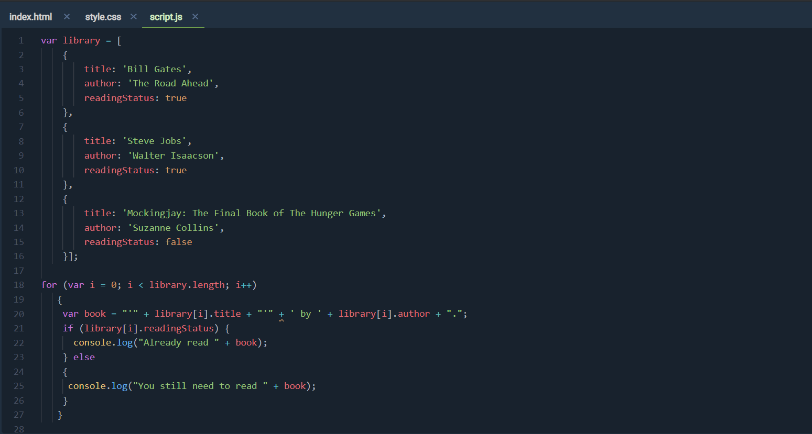

Output

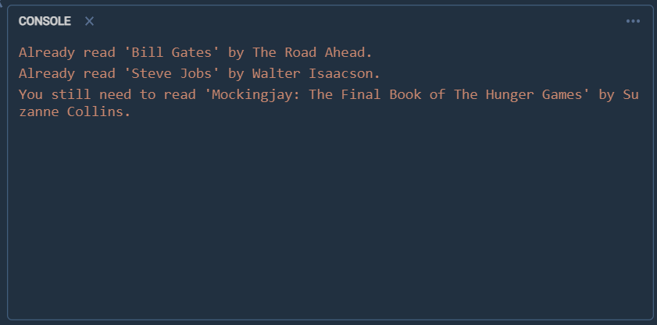

Q2Write a javascript program that generates an alert "Not legal age to drive" if the driver age is

below 18 years old, if driver age is greater than or equal to 18, it generates an alert "Drive safe".

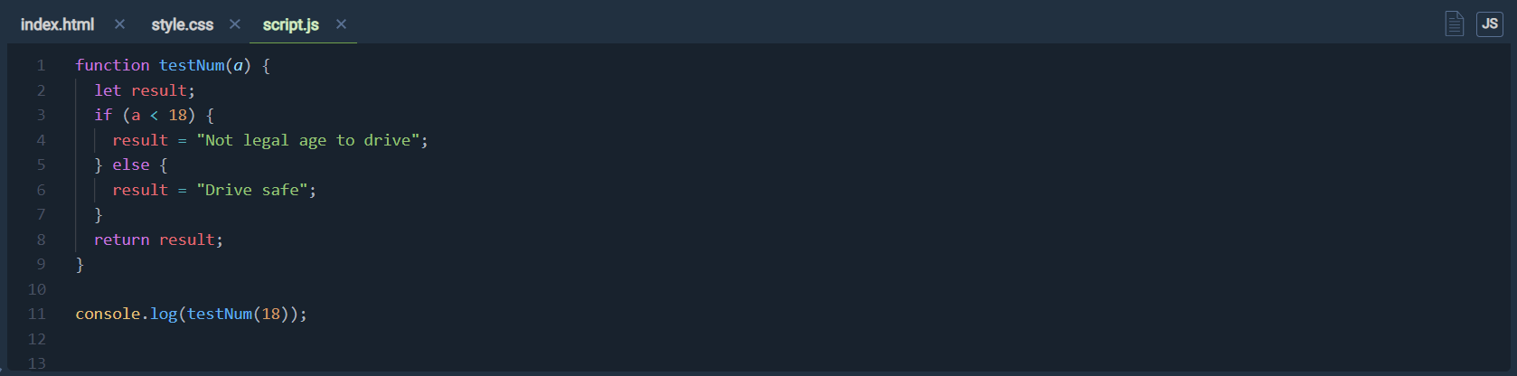

Output

